**SRI SAIRAM COLLEGE OF ENGINEERING ANEKAL, BENGALURU**

**DEPARTMENT OF COMPUTER SCIENCE AND**

**ENGINEERING**



DATA VISUALIZATION WITH PYTHON

BCS358D

LAB MANUAL

List of experiments

1.a) Write a python program to find the best of two test average marks out of three test’s marks accepted

from the user.

b) Develop a Python program to check whether a given number is palindrome or not andalso count the

number of occurrences of each digit in the input number.

2. a) Defined as a function F as Fn = Fn-1 + Fn-2. Write a Python program which accepts a value for N

(where N >0) as input and pass this value to the function. Display suitable error message if the condition

for input value is not followed.

b) Develop a python program to convert binary to decimal, octal to hexadecimal using functions.

3. a) Write a Python program that accepts a sentence and find the number of words, digits, uppercase letters and

lowercase letters.

b) Write a Python program to find the string similarity between two given strings.

4. a) Write a Python program to Demonstrate how to Draw a Bar Plot using Matplotlib.

b) Write a Python program to Demonstrate how to Draw a Scatter Plot using Matplotlib.

5. a) Write a Python program to Demonstrate how to Draw a Histogram Plot using Matplotlib.

b) Write a Python program to Demonstrate how to Draw a Pie Chart using Matplotlib.

6. a) Write a Python program to illustrate Linear Plotting using Matplotlib.

b) Write a Python program to illustrate liner plotting with line formatting using Matplotlib.

7. Write a Python program which explains uses of customizing seaborn plots with Aesthetic functions.

8. Write a Python program to explain working with bokeh line graph using Annotations and Legends.

a) Write a Python program for plotting different types of plots using Bokeh.

9. Write a Python program to draw 3D Plots using Plotly Libraries.

10. a) Write a Python program to draw Time Series using Plotly Libraries.

b) Write a Python program for creating Maps using Plotly Libraries.

1.a.Write a python program to find the best of two test average marks out of three test’s marks accepted from the user

m1 = int(input("Enter marks for test1 : "))

m2 = int(input("Enter marks for test2 : "))

m3 = int(input("Enter marks for test3 : "))

best_of_two = sorted([m1, m2, m3], reverse=True)[:2]

average_best_of_two = sum(best_of_two)/2

print("Average of best two test marks out of three test’s marks is", average_best_of_two);

Output:

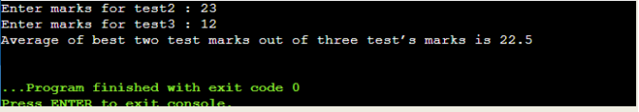

b.Develop a Python program to check whether a given number is palindrome or not andalso count the number of occurrences of each digit in the input number.

from collections import Counter

value = input("Enter a value : ")

if value == value[::-1]:

print("Palindrome")

else:

print("Not Palindrome")

counted_dict = Counter(value)

for key in sorted(counted_dict.keys()):

print(f'{key} appears {counted_dict[key]} times');

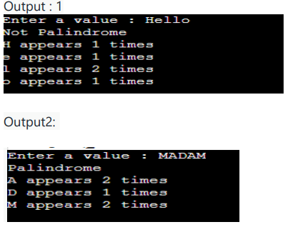

Q2. a) Defined as a function F as Fn = Fn-1 + Fn-2. Write a Python program which accepts a value for N (where N >0) as input and pass this value to the function. Display suitable error message if the condition for input value is not followed.

def fn(n):

if n <= 2:

return n - 1

else:

return fn(n-1) + fn(n-2)

try:

num = int(input("Enter a number : "))

if num > 0:

print(f' fn({num}) = {fn(num)}')

else:

print("Input should be greater than 0")

except ValueError:

print("Try with numeric value")

Ouput:

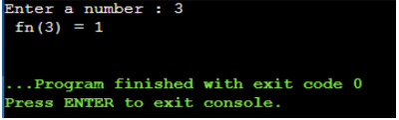

b) Develop a python program to convert binary to decimal, octal to hexadecimal using functions.

def bin2Dec(val):

return int(val, 2)

def oct2Hex(val):

return int(val, 8)

try:

num1 = input("Enter a binary number : ")

print(bin2Dec(num1))

except ValueError:

print("Invalid literal in input with base 2")

try:

num2 = input("Enter a octal number : ")

print(oct2Hex(num2))

except ValueError:

print("Invalid literal in input with base 8")

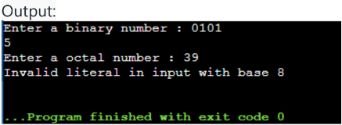

Ex .3. Write a Python program that accepts a sentence and find the number of

words, digits, uppercase letters and lowercase letters.

import string

sentence = input("Enter a sentence : ")

wordList = sentence.strip().split(" ")

print(f'This sentence has {len(wordList)} words', end='\n\n')

digit_count = uppercase_count = lowercase_count = 0

for character in sentence:

if character in string.digits:

digit_count += 1

elif character in string.ascii_uppercase:

uppercase_count += 1

elif character in string.ascii_lowercase:

lowercase_count += 1

print(f'This sentence has {digit_count} digits',

f' {uppercase_count} upper case letters',

f' {lowercase_count} lower case letters', sep='\n')

Output:

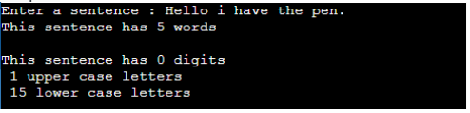

b) Write a Python program to find the string similarity between two given strings

from difflib import SequenceMatcher

str1 = input("Enter String 1 : ")

str2 = input("Enter String 2 : ")

sim = SequenceMatcher(None, str1, str2).ratio()

print("Similarity between strings \"" + str1 + "\" and \"" + str2 + "\" is : ",sim)

Output:

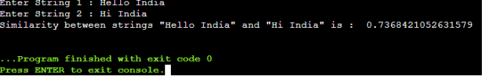

Q4. a) Write a Python program to Demonstrate how to Draw a Bar Plot using

Matplotlib.

import matplotlib.pyplot as plt

categories = ['0-10', '10-20', '20-30', '30-40', '40-50']

values = [55, 48, 25, 68, 90]

plt.bar(categories, values, color='skyblue')

plt.xlabel('Overs')

plt.ylabel('Runs')

plt.title('Bar Plot Showing Runs scored in an ODI Match')

plt.show()

Output:

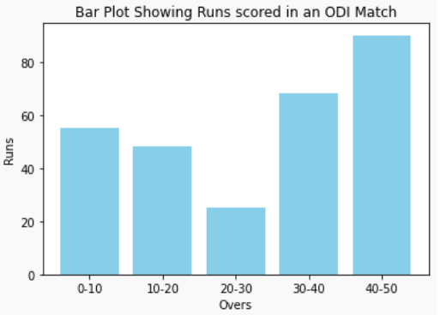

b) Write a Python program to Demonstrate how to Draw a Scatter Plot using

Matplotlib.

import matplotlib.pyplot as plt

countries = ['Brazil', 'Russia', 'India', 'China', 'South Africa']

population = [213993437, 145912025, 1393409038, 1444216107, 61608912]

per_capita_income = [9600, 11600, 2300, 11000, 6500]

circle_size = [pop / 1000000 for pop in population]

colors = np.arange(len(countries))

scatter = plt.scatter(population, per_capita_income, s=circle_size, c=colors, cmap='viridis', alpha=0.7, label='BRICS Nations')

for i, country in enumerate(countries):

plt.annotate(country, (population[i], per_capita_income[i]), textcoords="offset points", xytext=(0,5), ha='center')

plt.colorbar(scatter, label='Index')

plt.xlabel('Population')

plt.ylabel('Per Capita Income (USD)')

plt.title('Population vs Per Capita Income of BRICS Nations')

plt.show()

Output:

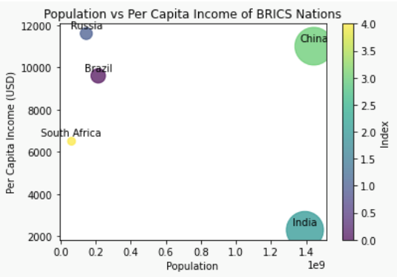

**Q5. a) Write a Python program to Demonstrate how to Draw a Histogram Plot**

**using Matplotlib.**

import matplotlib.pyplot as plt

import numpy as np

np.random.seed(42)

student_scores = np.random.normal(loc=70, scale=15, size=100)

plt.hist(student_scores, bins=20, color='skyblue', edgecolor='black')

plt.xlabel('Student Scores')

plt.ylabel('Frequency')

plt.title('Distribution of Student Scores')

plt.show()

**Output :**

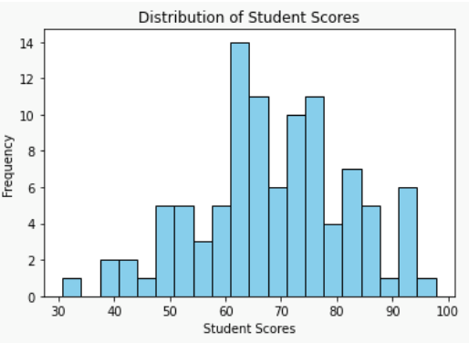

**b) Write a Python program to Demonstrate how to Draw a Pie Chart using**

**Matplotlib.**

import matplotlib.pyplot as plt

countries = ['Brazil', 'Germany', 'Italy', 'Argentina', 'Uruguay', 'France', 'England','Spain']

wins = [5, 4, 4, 3, 2, 2, 1, 1]

colors = ['yellow', 'magenta', 'green', 'blue', 'lightblue', 'blue', 'red', 'cyan']

plt.pie(wins, labels=countries, autopct='%1.1f%%', colors=colors, startangle=90,

explode=[0.2, 0.2, 0.2, 0.2, 0.2, 0.2, 0.2, 0.2], shadow=True)

plt.title('FIFA World Cup Wins by Country')

plt.axis('equal') # Equal aspect ratio ensures that the pie chart is circular.

plt.show()

**Output:**

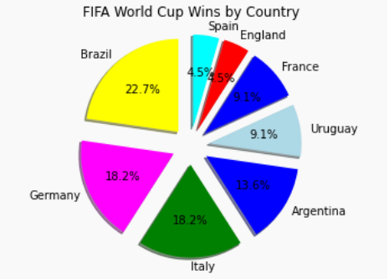

Q6. a) Write a Python program to illustrate Linear Plotting using Matplotlib.

import matplotlib.pyplot as plt

overs = [0,1,2,3,4,5,6,7,8,9,10,11,12,13,14,15,16,17,18,19,20]

runs_scored = [0,7,12,20,39,49,61,83,86,97,113,116,123,137,145,163,172,192,198,198,203]

plt.plot(overs, runs_scored)

plt.xlabel('Overs')

plt.ylabel('Runs scored')

plt.title('Run scoring in an T20 Cricket Match')

plt.grid(True)

plt.show()

Output:

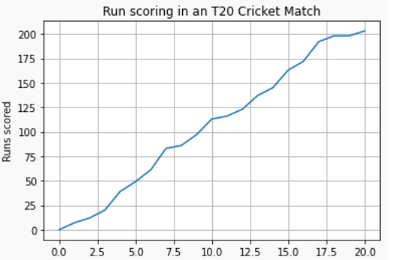

b) Write a Python program to illustrate liner plotting with line formatting using Matplotlib.

import matplotlib.pyplot as plt

overs = [0,1,2,3,4,5,6,7,8,9,10,11,12,13,14,15,16,17,18,19,20]

runs_scored = [0,7,12,20,39,49,61,83,86,97,113,116,123,137,145,163,172,192,198,198,203]

plt.plot(overs, runs_scored, marker='X', linestyle='dashed',color='red', linewidth=2, markerfacecolor='blue', markersize=8)

plt.xlabel('Overs', color = 'green')

plt.ylabel('Runs scored')

plt.title('Run scoring in an T20 Cricket Match')

plt.grid(True)

plt.show()

Output:

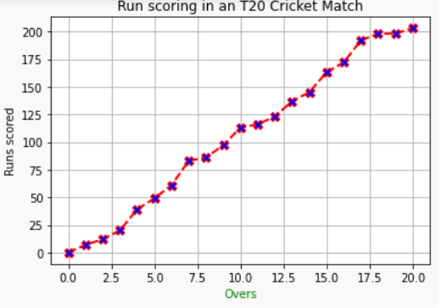

Q7. Write a Python program which explains uses of customizing seaborn plots with Aesthetic functions.

import numpy as np

import matplotlib.pyplot as plt

import seaborn as sns

def sinplot(n=10):

x = np.linspace(0, 14, 100)

for i in range(1, n + 1):

plt.plot(x, np.sin(x + i * .5) * (n + 2 - i))

sns.set()

sns.set_context("notebook", font_scale=1.5, rc={"lines.linewidth": 2.5})

sinplot()

plt.title('Seaborn plots with Aesthetic functions')

plt.show()

Output :

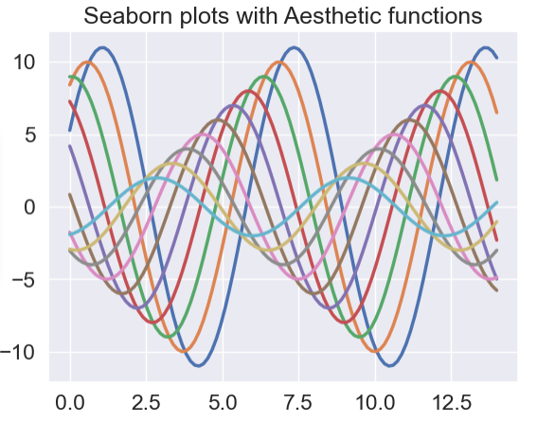

**Q8.** Write a Python program to explain working with bokeh line graph using

Annotations and Legends.

Write a Python program for plotting different types of plots using Bokeh.

import numpy as np

from bokeh.layouts import gridplot

from bokeh.plotting import figure, show

x = np.linspace(0, 4*np.pi, 100)

y = np.sin(x)

TOOLS = "pan,wheel_zoom,box_zoom,reset,save,box_select"

p1 = figure(title="Example 1", tools=TOOLS, width=400, height=400)

p1.circle(x, y, legend_label="sin(x)")

p1.circle(x, 2*y, legend_label="2*sin(x)", color="orange")

p1.circle(x, 3*y, legend_label="3*sin(x)", color="green")

p1.legend.title = 'Markers'

p2 = figure(title="Example 2", tools=TOOLS, width=400, height=400)

p2.circle(x, y, legend_label="sin(x)")

p2.line(x, y, legend_label="sin(x)")

p2.line(x, 2*y, legend_label="2*sin(x)",

line_dash=(4, 4), line_color="orange", line_width=2)

p2.square(x, 3*y, legend_label="3*sin(x)", fill_color=None, line_color="green")

p2.line(x, 3*y, legend_label="3*sin(x)", line_color="green")

p2.legend.title = 'Lines'

show(gridplot([p1, p2], ncols=2))

Output:

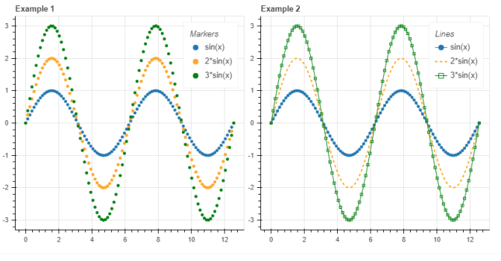

**Q9. Write a Python program to draw 3D Plots using Plotly Libraries**

import plotly.graph_objects as go

import numpy as np

x = np.linspace(-5, 5, 100)

y = np.linspace(-5, 5, 100)

x, y = np.meshgrid(x, y)

z = np.sin(np.sqrt(x**2 + y**2))

fig = go.Figure(data=[go.Surface(z=z, x=x, y=y)])

fig.update_layout(scene=dict(

xaxis_title='X Axis',

yaxis_title='Y Axis',

zaxis_title='Z Axis'),

margin=dict(l=0, r=0, b=0, t=40),

title='3D Surface Plot of sin(sqrt(x^2 + y^2))')

fig.show()

Output:

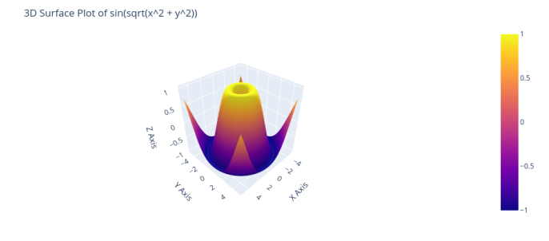

Q10. a) Write a Python program to draw Time Series using Plotly Libraries.

import pandas as pd

import plotly.express as px

dollar_conv = pd.read_csv('CUR_DLR_INR.csv')

fig = px.line(dollar_conv, x='DATE', y='RATE', title='Dollar vs Rupee')

fig.show()

OUTPUT:

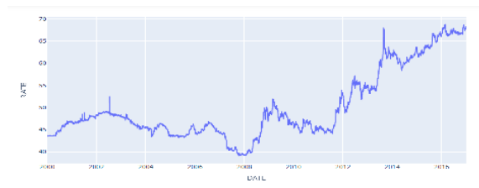

b) Write a Python program for creating Maps using Plotly Libraries.

import plotly.express as px

import pandas as pd

data =

pd.read_csv('https://raw.githubusercontent.com/plotly/datasets/master/gapmind

er_with_codes.csv')

fig = px.choropleth(data, locations='iso_alpha', color='gdpPercap',

hover_name='country',

projection='natural earth', title='GDP per Capita by Country')

fig.show()

OUTPUT:

